
SMART-BIN: AN ESP32-BASED IoT WASTE BIN MONITORING SYSTEM WITH FILL, WEIGHT, AIR-QUALITY AND TAMPER DETECTION
FOR PRIORITY-BASED COLLECTION

Waste Management and Cleanliness
Problem: Overflowing Garbage Bins and Inefficient Waste Collection Routes

Technological University of the Philippines - Manila
Bachelor of Engineering Technology major in Computer Engineering Technology

Embedded Systems: Final Project
BET-CPET 4A-M, Group 2

Submitted By:
Brian Jay Celeste
Genesis Walter D. Reyes II
Jade C. Gunayan
King Perth G. Pepito
Rodel S. Banogbanog

Submitted To:
Prof. Jonel R. Macalisang

November 6, 2026
TABLE OF CONTENTS
TITLE PAGE i
TABLE OF CONTENTS ii
LIST OF FIGURES iii
LIST OF TABLES iv
I. INTRODUCTION 1
1.1 Introduction and Problem 1
1.2 Sustainable Development Goal (SDG) Addressed 2
1.3 Review of Related Literature 3
1.4 Objectives 4
1.5 Conceptual Framework 5
1.6 Target Beneficiaries 6
II. PROTOTYPE DESIGN AND DEVELOPMENT 7
2.1 Prototype Design 7
2.2 Block Diagram 8
2.3 System Flowchart 10
2.4 Schematic Design 12
2.5 Component Materials 15
III. TESTING, RESULTS, AND CONCLUSION 26
3.1 Test Cases 26
3.2 Results and Discussion 26
3.3 Conclusion 26
3.4 Recommendations 26
REFERENCES 27
APPENDICES 29
Appendix A: Gantt Chart 29
Appendix B: Bill of Materials 30
Appendix C: User Interface Screens 31
Appendix D: Source Code 32

LIST OF FIGURES
Figure 1. Sustainable Development Goal 11: Sustainable Cities and Communities 2
Figure 2. Block Diagram of the Smart-Bin System 8
Figure 3. System Flowchart of the Smart-Bin 10
Figure 4. Schematic Diagram, Sheet 1: Microcontroller 12
Figure 5. Schematic Diagram, Sheet 2: Actuators and Outputs 13
Figure 6. Schematic Diagram, Sheet 3: Sensors and Inputs 14
Figure 7. ESP32 DevKit V1 (38-Pin, ESP32-WROOM-32D) 15
Figure 8. HC-SR04 Ultrasonic Distance Sensor 16
Figure 9. HC-SR501 PIR Motion Sensor 17
Figure 10. BME680 Environmental Sensor 18
Figure 11. BMI160 Six-Axis Inertial Measurement Unit 19
Figure 12. HX711 Load Cell Amplifier and 5kg Load Cell 20
Figure 13. SG90 Micro Servo Motor 21
Figure 14. 2.4-in. TFT Touchscreen (ILI9341 With XPT2046 Touch Controller) 22
Figure 15. KY-016 RGB LED Module 23
Figure 16. Passive Buzzer Module (MH-FMD) 24
Figure 17. 18650 Battery Shields for Bin A (4-Cell) and Bin B (2-Cell) 25
LIST OF TABLES
Table 1. Bill of Materials of the Smart-Bin Prototype 30

I. INTRODUCTION

1.1 Introduction and Problem
An effective waste management plays a crucial role in creating and sustaining healthy, clean and prosperous communities. With the rising amount of waste that is being generated, it has become a problem for the local government and commercial waste collectors in the Philippines. The Philippines is estimated to be producing a total of 60.76 thousand tons of garbage every day in 2025, according to the Philippine Statistics Authority (PSA, 2026). Despite the significant actions taken by the City of Metro Manila, its garbage is projected to reach 9,498 MT/D in 2020, making it the country's waste capital (World Bank, 2022). This was projected to rise to 10,368 MT per day by 2025 (World Bank, 2022). Hence, a high priority of improving waste management and collection practices in the country. Most garbage collection systems are conducted on a fixed schedule, causing bins to overflow when they are picked up or not to be filled to capacity when collected. Additionally, the smell, pollution levels, temperature, tilting of garbage bins, and unauthorized access should also be monitored as they are important indicators of environmental conditions and the efficiency of garbage management.
The researchers propose the Smart-Bin which is an Internet of Things (IoT) based bin monitoring system based on the ESP32 microcontroller with the aim of improving garbage collection performance. Sensors will be used by Smart-Bin to determine the level of fullness, weight, temperature, humidity, and air quality. It'll also be tracking bins that tilt irregularly, and any unauthorized bin openings, through a web dashboard and mobile application. Smart-Bin includes a touchscreen at the bin for employees to view and acknowledge the collection instructions, as well as to set up PIN codes to select who can access the bin, and to make collection setting changes. The project will include the development of two Smart-Bin prototypes built at the table size that will feature the ESP32 boards, local Wi-Fi, ThingSpeak, web dashboard, Android app, and screen at the bin. Smart-Bin will arrange the list of collection priorities based on fill levels and how long they will take to fill up, with the aim of optimizing garbage collection and fuel consumption rates.

1.2 Sustainable Development Goal (SDG) Addressed
Figure 1
Sustainable Development Goal 11: Sustainable Cities and Communities

The project Smart-Bin is connected to one of the Sustainable Development Goals (SDGs) of the United Nations (Agenda 2030), namely SDG 11: Sustainable Cities and Communities. Smart-Bin is specifically targeting the environmental impact of cities, per capita, with particular attention to air quality and municipal and other waste management (United Nations Department of Economic and Social Affairs [UN DESA], n.d., Target 11.6).
Smart-Bin can contribute to achieve the target of Sustainable Development Goal 11. It is achieved by monitoring and control of waste state with help of sensors installed in smart-bins and collecting information to make timely decision to ensure waste management collection process. As part of the project, a dashboard and application are developed and send a notification to the operator regarding of the bins state (levels, weight, temperatures, humidity, air quality around bins).
It can help in optimizing the collection process since priority can be given to those bins which have more trash and need to be emptied before the trash overflows. Furthermore, it can be used to prevent the impact on the environment, for example, if the air quality is not acceptable. This can optimize the collection process by prioritizing bins and minimizing vehicles and fuel usage.

1.3 Review of Related Literature
[Introduce the review of related literature here.]

Prior Art
[Discuss 15 to 20 existing smart bin products, patents, or prototypes.]

Related Literature and Studies
[Discuss 20 to 30 related literature and studies published in 2023 or later.]

SWOT Analysis
[Insert the SWOT analysis of Smart-Bin here.]

Research Gap
[State the gap in existing systems that Smart-Bin addresses.]

1.4 Objectives

General Objective
To design and develop Smart-Bin, an IoT based Waste Bin Monitoring System which will monitor the fill level, weight and air quality of the waste bin, detect tampering and give real time monitoring and alerts to the concerned entities via Web Based Dashboard, Android App and On-Bin Touchscreen.

Specific Objectives
- Sensor Monitoring and Detection
To develop 2 Smart-Bin units, which include sensors to measure fill level, weight, temperature, humidity and air quality, as well as to detect bin tilting and tampering and open the lid automatically when hand movement is detected.
- Real-Time Monitoring and Alerts
To build a web dashboard and Android app to show real-time sensor data, bin status, retrieve data from ThingSpeak and alert operators and collectors when bins are full, air quality is poor, there is high temperature, tampering or when the bin is not online.
- Bin Control and Collection Prioritization
To implement Collection Prioritization, based on bin fullness and estimated time to fullness, remote bin locking and unlocking, on-bin collection functions (via PIN), sensor simulation and system interface sensor calibration. This will lead to the prioritization of collections and will also help with efficient collection routes and fuel gas efficiency.

1.5 Conceptual Framework
[Introduce the conceptual framework here.]

Input-Process-Output Model
[Insert and explain the IPO diagram here.]

IoT Level
[Explain the IoT level of the system (Bahga & Madisetti) here.]

1.6 Target Beneficiaries
- Waste Collectors and Utility Staff
Smart-Bin will assist waste collectors and utility workers by notifying them which bins are fullest and need to be emptied first. It could also prevent visits to bins that are not full and offer PIN access to the bin during collection.
- Facility Managers and Operators
Facility managers and operators of schools, offices, malls, and barangay halls will benefit from the web dashboard as it allows them to monitor the status of the bins, evaluate the data, set thresholds for sensors, and receive alerts such as messages regarding overflowing bins, poor air quality, high temperature, and possible tampering.
- Barangay and Local Government Unit (LGU) Sanitation Offices
The sanitation offices of barangays and LGUs can utilize Smart-Bin's data readings to aid in garbage collection scheduling and management. Information on the percentage of fullness and time to be full can help them optimize collection routes and reduce fuel consumption by avoiding unnecessary pickups.
- Filipino Citizens
Filipino citizens like students, employees, and residents of schools, offices, or other places would benefit from cleaner surroundings, fewer overflowing trash bins, and more awareness about waste. The hands-free lid would also make it easier and more sanitary to dispose of waste.

II. PROTOTYPE DESIGN AND DEVELOPMENT

2.1 Prototype Design
[Describe and show the physical design of the Smart-Bin prototype here.]

2.2 Block Diagram
Figure 2 shows the block diagram of one Smart-Bin unit and the network around it. Each of the two bins has its own ESP32 microcontroller, and both bins report to the same cloud services and user apps.
Figure 2
Block Diagram of the Smart-Bin System
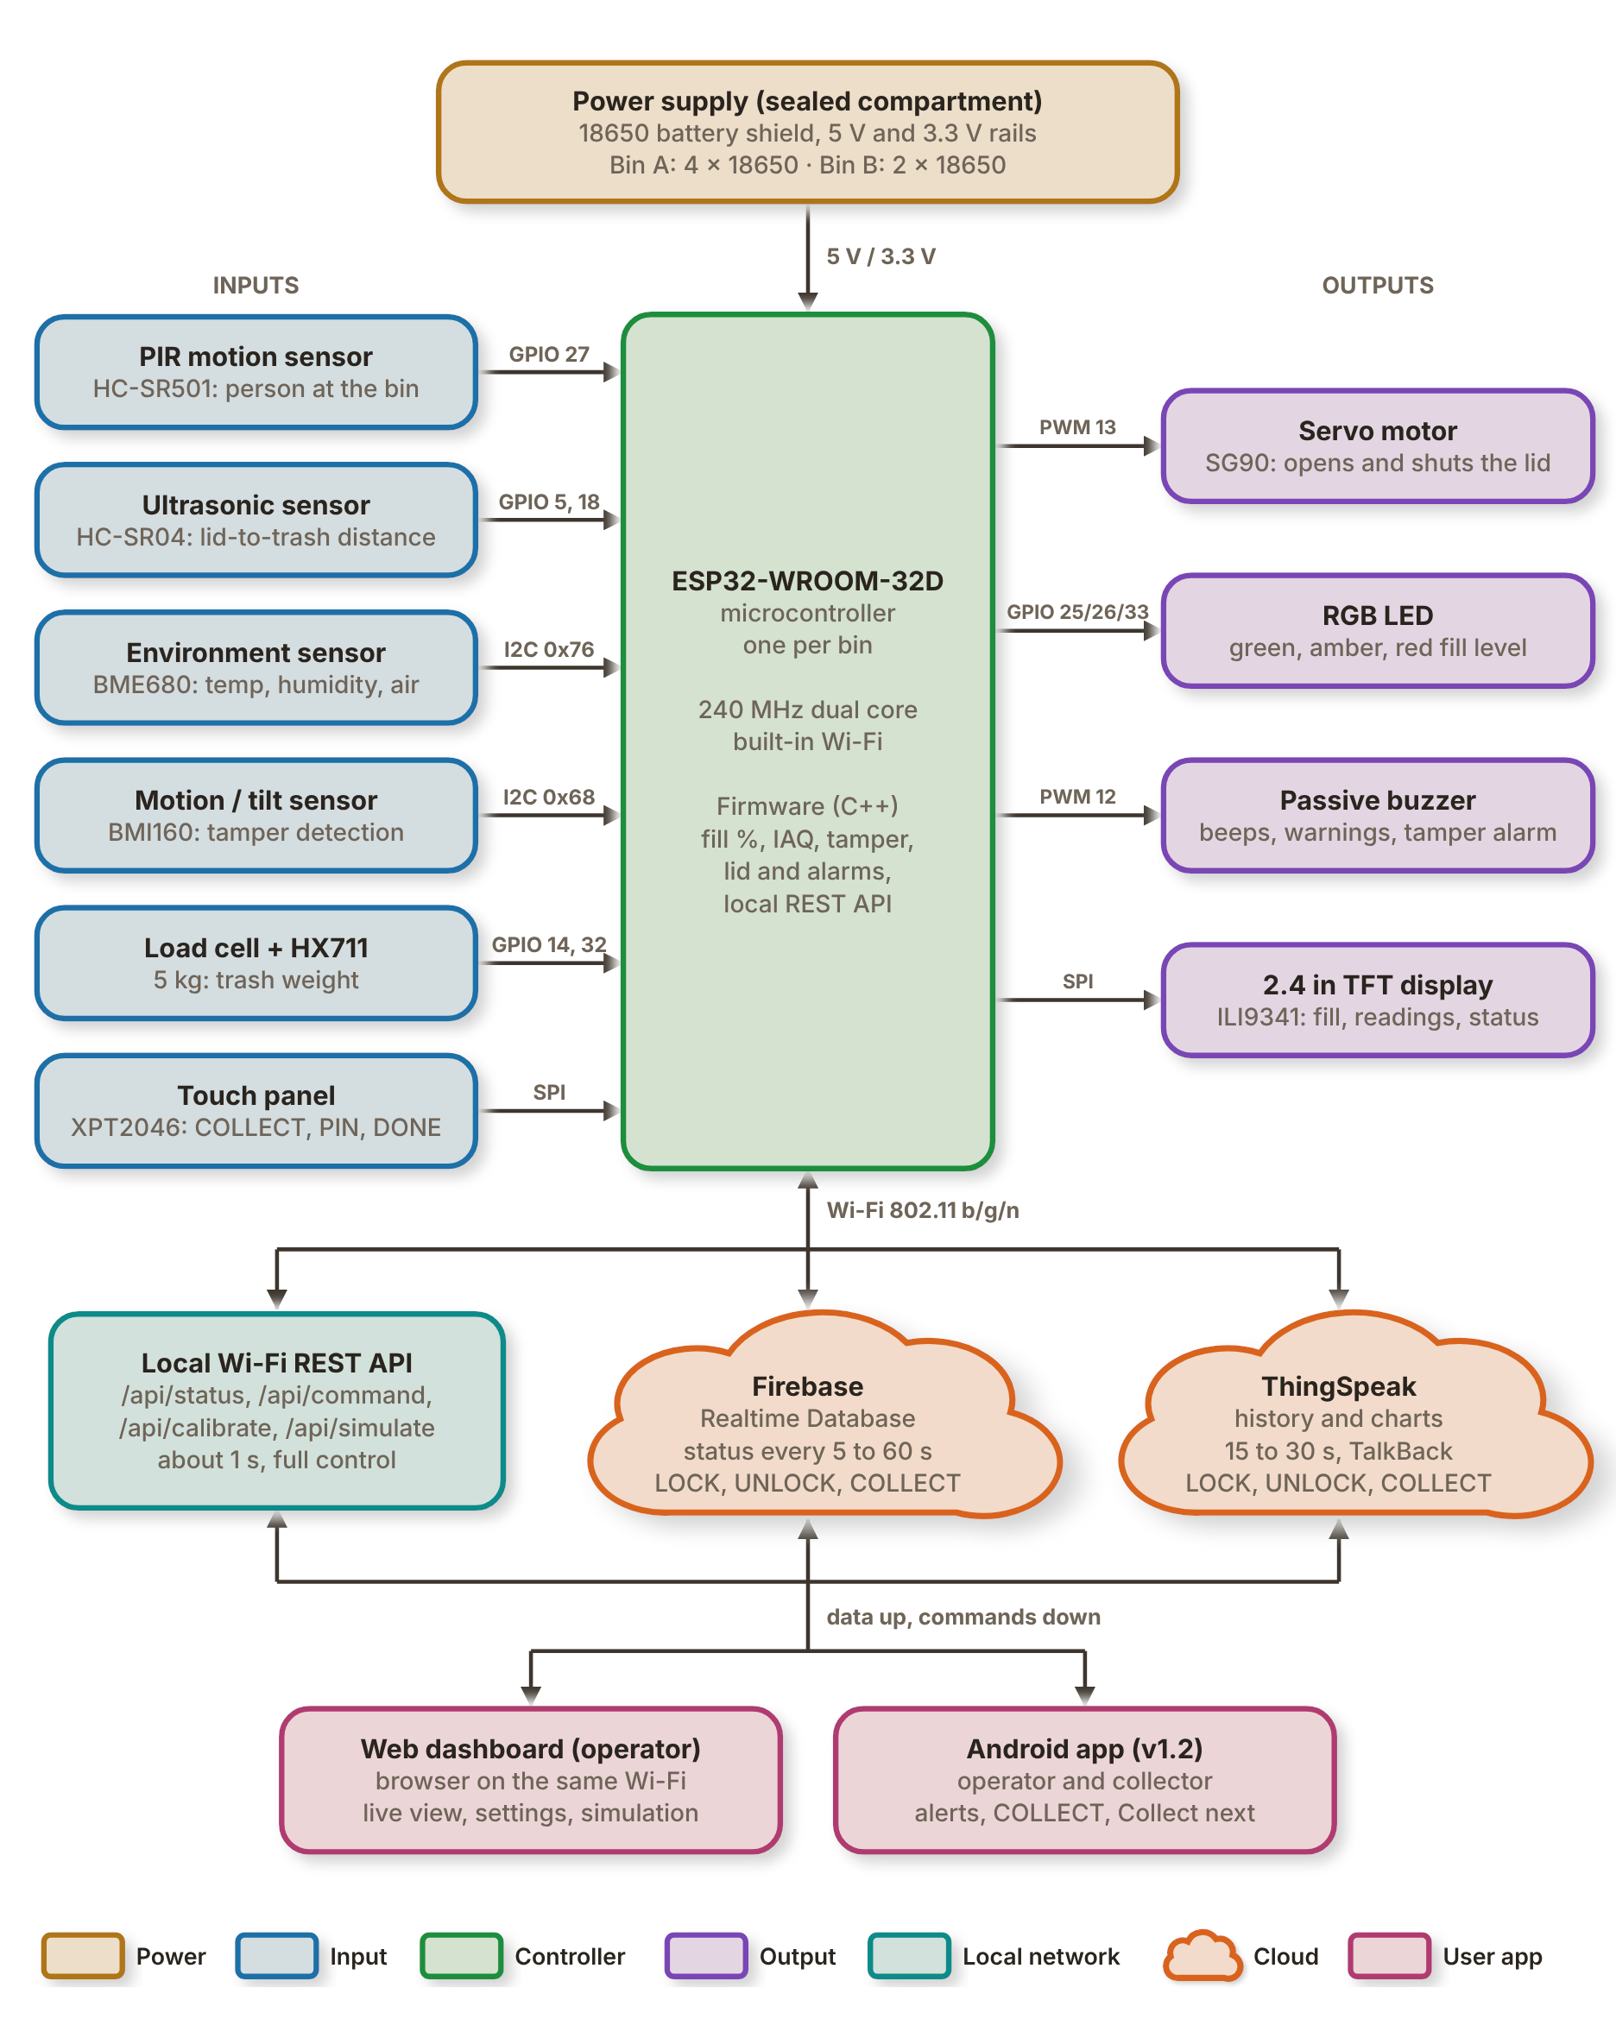
At the top of the diagram is the power supply, an 18650 battery shield kept in a sealed compartment. It gives the circuit a 5V rail and a 3.3V rail. Bin A runs on four 18650 cells and Bin B on two. Both rails feed the ESP32-WROOM-32D, a 240MHz dual-core microcontroller with built-in Wi-Fi. Its firmware, written in C++, computes the fill percentage, the indoor air quality (IAQ) reading and the tamper state, drives the lid and the alarms, and serves a local REST API.
The inputs sit on the left. The HC-SR501 PIR sensor on GPIO 27 detects a person at the bin, and the HC-SR04 ultrasonic sensor on GPIO 5 and 18 measures the distance from the lid to the trash, which gives the fill level. Two sensors share the I2C bus: the BME680 at address 0x76 reads temperature, humidity and air quality, while the BMI160 at 0x68 senses motion and tilt for tamper detection. A 5kg load cell with an HX711 amplifier on GPIO 14 and 32 weighs the trash. The XPT2046 touch panel on SPI takes the COLLECT, PIN and DONE inputs.
The outputs sit on the right. The SG90 servo on PWM pin 13 opens and shuts the lid. An RGB LED on GPIO 25, 26 and 33 shows the fill level in green, amber or red, and a passive buzzer on PWM pin 12 sounds beeps, warnings and the tamper alarm. The 2.4 in. ILI9341 TFT display, also on SPI, shows the fill level, the sensor readings and the bin status.
The lower half shows how data leaves the bin over Wi-Fi (802.11 b/g/n) through three paths. The local REST API (/api/status, /api/command, /api/calibrate and /api/simulate) answers in about 1s and gives full control of the bin. Firebase Realtime Database receives the status every 5 to 60s, and ThingSpeak stores the history and charts every 15 to 30s; both also carry the LOCK, UNLOCK and COLLECT commands, ThingSpeak through its TalkBack feature. Data goes up and commands come down to two user apps. The web dashboard runs in a browser on the same Wi-Fi and gives the operator a live view, settings and simulation, while the Android app gives operators and collectors alerts, the COLLECT command and the Collect next list.

2.3 System Flowchart
Figure 3 traces how a Smart-Bin unit runs from start-up to a finished collection. The left column covers everyday use of the bin, and the right column covers the collection cycle that a full bin triggers.
Figure 3
System Flowchart of the Smart-Bin
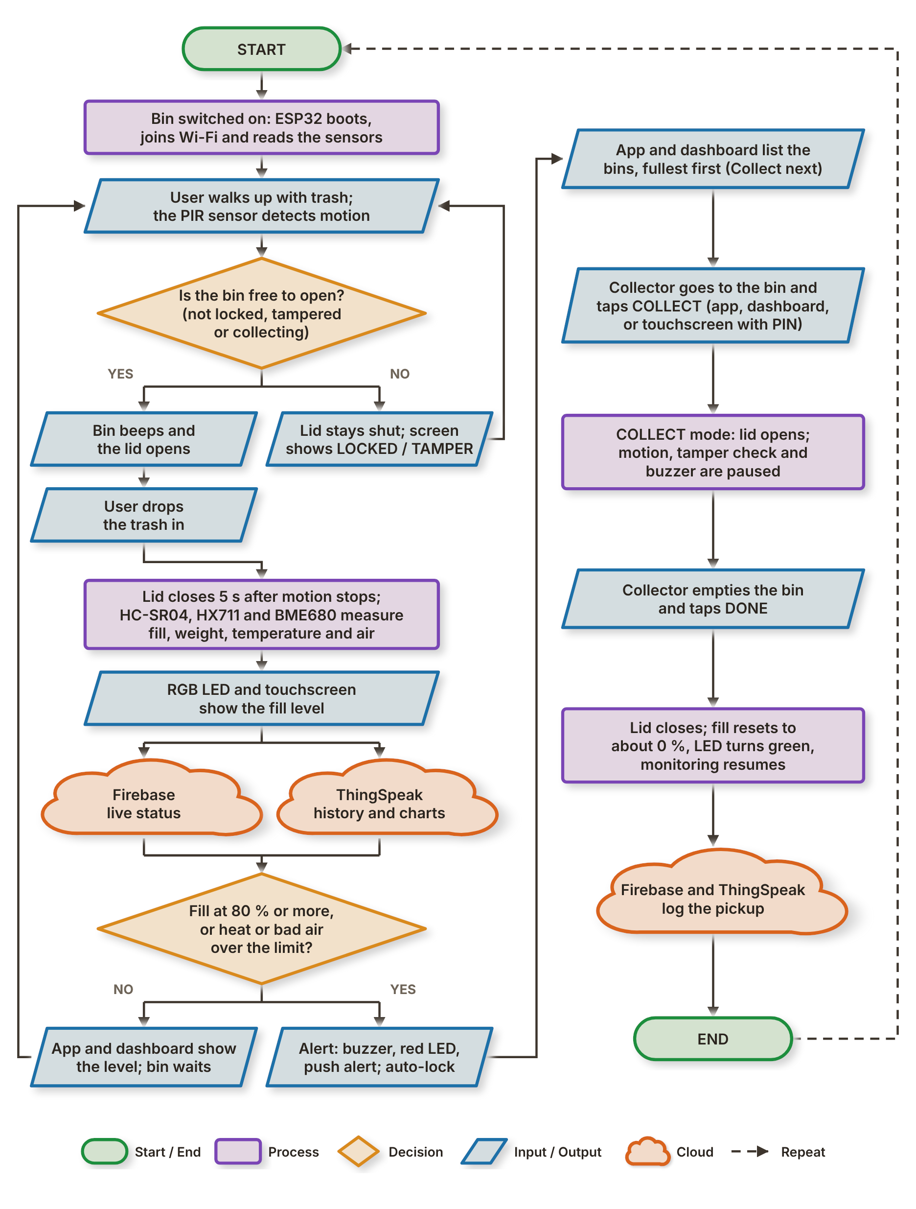
When the bin is switched on, the ESP32 boots, joins the Wi-Fi network and starts reading its sensors. A user who walks up with trash is picked up by the PIR sensor. The firmware then checks whether the bin is free to open, which means it is not locked, not flagged for tampering and not in collection mode. If it is not free, the lid stays shut and the touchscreen shows LOCKED or TAMPER. If it is free, the bin beeps and the lid opens so the user can drop the trash in.
The lid closes 5s after motion stops. The HC-SR04, HX711 and BME680 then measure the fill level, weight, temperature and air, and the RGB LED and touchscreen show the new fill level. The same readings go to Firebase for the live status and to ThingSpeak for history and charts. Next comes the main decision: is the bin at 80% full or more, or is the heat or bad air over its limit? If not, the app and dashboard show the level and the bin waits for the next user. If so, the buzzer sounds, the LED turns red, a push alert goes out and the bin locks itself.
That alert starts the collection cycle in the right column. The app and dashboard list the bins with the fullest first under Collect next. A collector goes to the bin and taps COLLECT on the app, on the dashboard or on the touchscreen with a PIN. In COLLECT mode the lid opens, and motion sensing, the tamper check and the buzzer are paused so the collector can work. Once the bin is empty the collector taps DONE. The lid closes, the fill level resets to about 0%, the LED turns green and monitoring resumes. Firebase and ThingSpeak log the pickup, and the process loops back to the start.

2.4 Schematic Design
The circuit of each unit is drawn as one schematic split into three sheets: the microcontroller, the actuators and outputs, and the sensors and inputs. Figures 4 to 6 show the sheets in that order. Instead of long wires between sheets, each connection to the ESP32 carries a net label such as IO25, and pins with the same label are joined.
Figure 4
Schematic Diagram, Sheet 1: Microcontroller
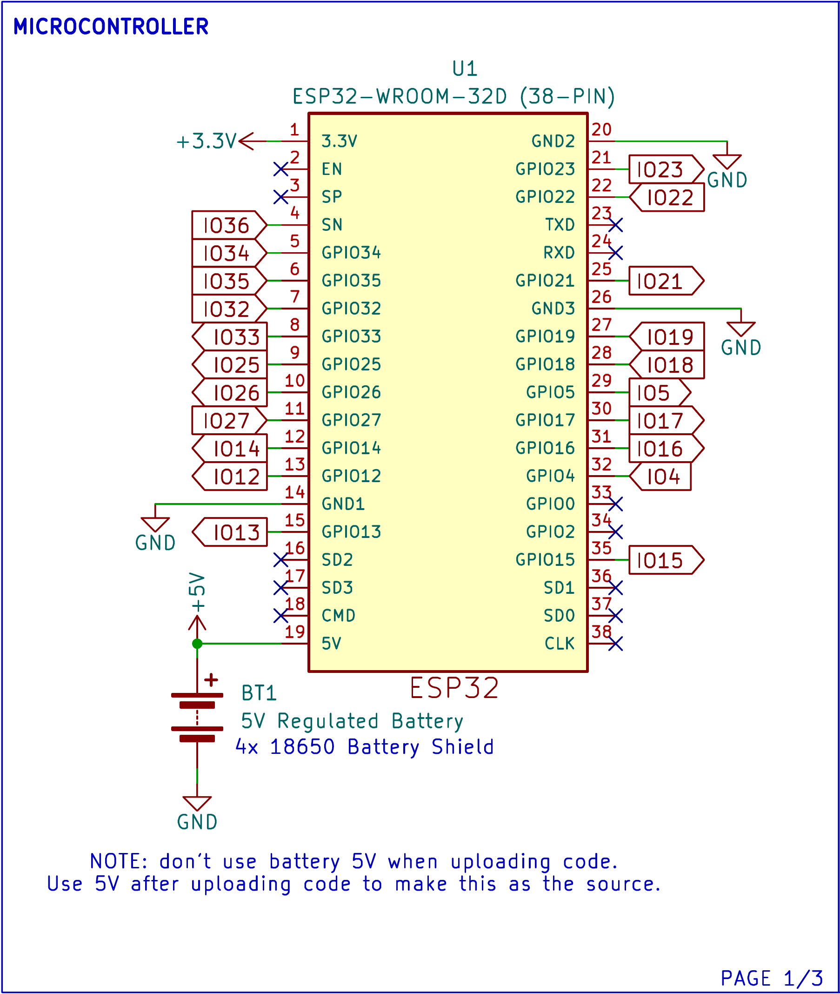
U1 is the ESP32-WROOM-32D on a 38-pin board. BT1, the 4 × 18650 battery shield, supplies a regulated 5V to pin 19, and pin 1 gives the 3.3V rail used by the sensors. The ground pins share one GND net. Pins that the design does not use, such as EN, TXD, RXD, GPIO0 and GPIO2, are marked no-connect. A note on the sheet says the battery's 5V must not be used while code is being uploaded; it becomes the power source only after the upload.
Figure 5
Schematic Diagram, Sheet 2: Actuators and Outputs
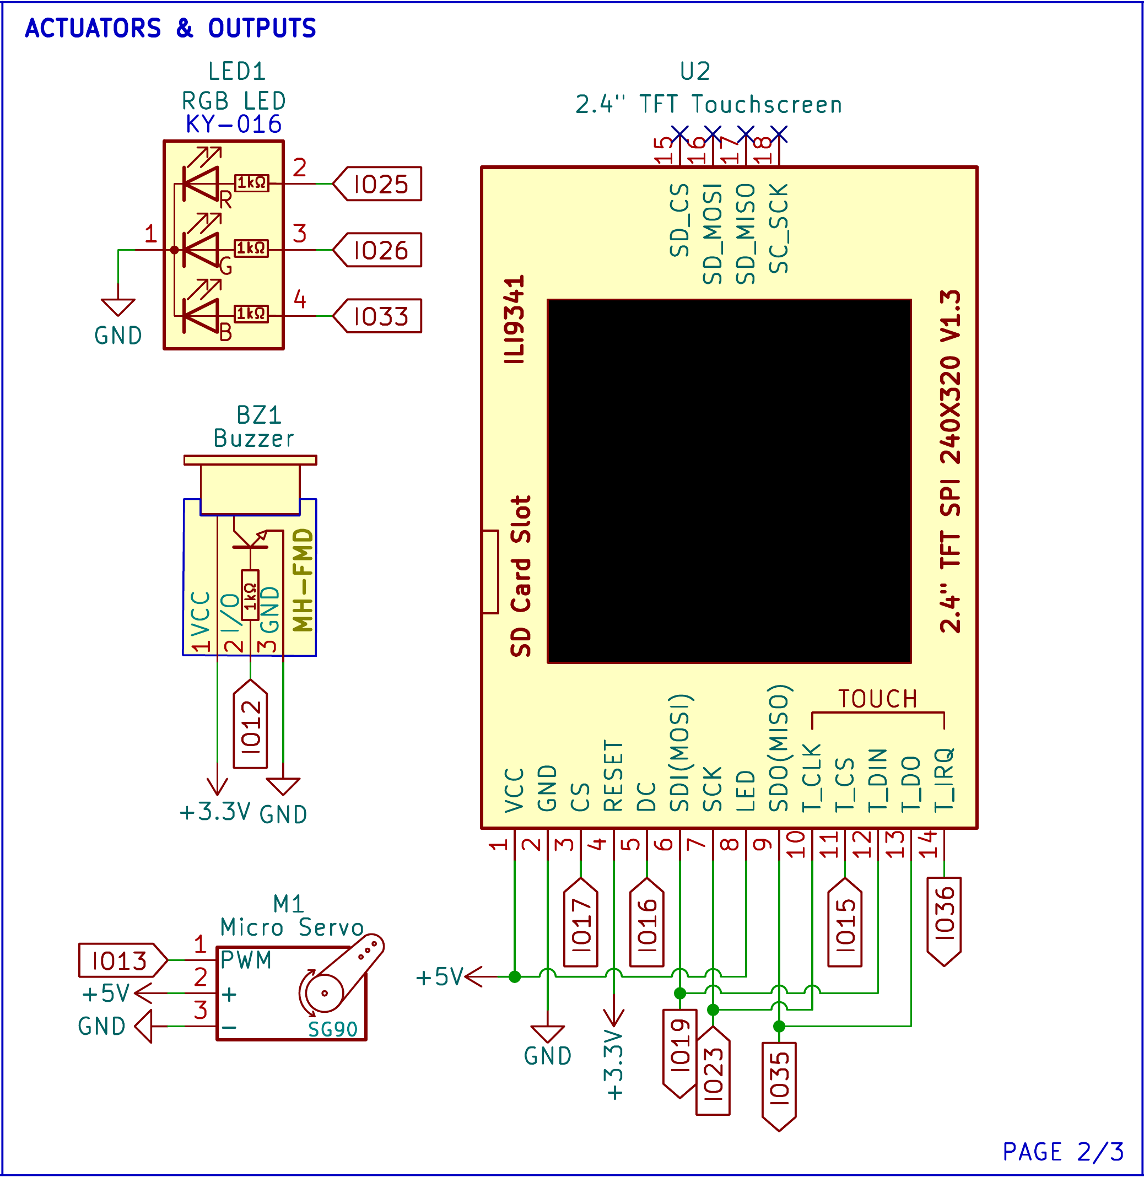
LED1 is a KY-016 common-cathode RGB LED. Its red, green and blue legs go through 1kΩ resistors to IO25, IO26 and IO33. BZ1, an MH-FMD buzzer module, runs on 3.3V and is driven from IO12. M1, the SG90 micro servo, takes 5V and its PWM signal from IO13.
U2 is the 2.4 in. ILI9341 touchscreen (240 × 320, SPI). The display and its touch controller share the SPI clock and data lines on IO19, IO23 and IO35, and each has its own chip select: IO17 for the display and IO15 for touch. DC goes to IO16, the touch interrupt T_IRQ to IO36, and RESET is tied to 3.3V. VCC and the backlight pin take 5V. The SD card pins are left unconnected.
Figure 6
Schematic Diagram, Sheet 3: Sensors and Inputs
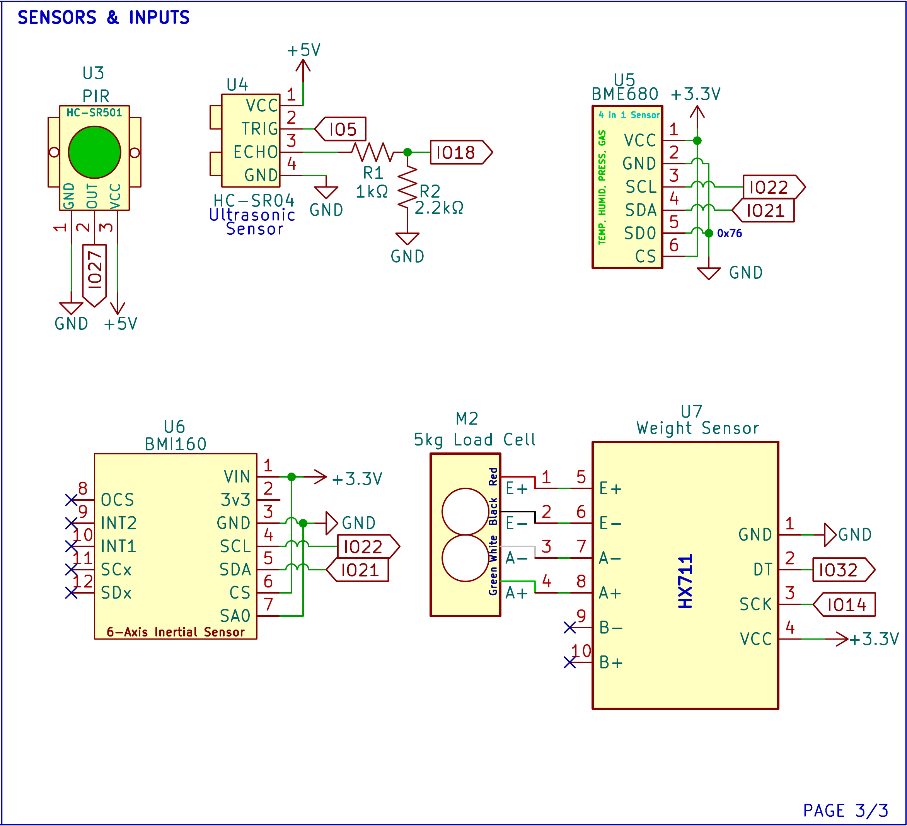
U3, the HC-SR501 PIR sensor, runs on 5V and sends its output to IO27. U4, the HC-SR04, also runs on 5V, with TRIG on IO5. Its ECHO pin returns a 5V pulse, so R1 (1kΩ) and R2 (2.2kΩ) divide it to about 3.4V before it reaches IO18, which keeps the ESP32 input within its 3.3V rating.
U5 (BME680) and U6 (BMI160) both run on 3.3V and share the I2C bus, with SCL on IO22 and SDA on IO21. Tying the BME680's SDO pin to ground sets its address to 0x76, and tying the BMI160's SA0 pin to ground sets its address to 0x68, so the two do not clash. M2, the 5kg load cell, connects its red, black, white and green wires to the E+, E−, A− and A+ inputs of U7, the HX711. The HX711 runs on 3.3V and sends its data on IO32 with its clock on IO14.

2.5 Component Materials
This section describes the main electronic parts used in each Smart-Bin unit. Both bins use the same parts except for the battery shield. Figures 7 to 17 show each part, followed by what it does and how the system uses it.
Figure 7
ESP32 DevKit V1 (38-Pin, ESP32-WROOM-32D)
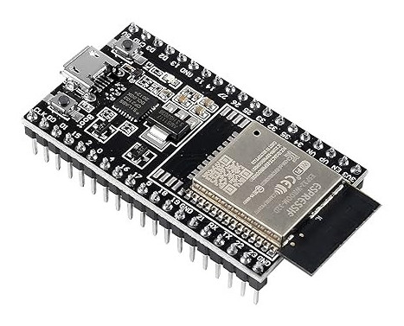
Note. Image from Sigmanortec, n.d..
The ESP32 DevKit V1 is a development board built around the ESP32-WROOM-32D module. The module has a dual-core processor that runs at up to 240MHz, with Wi-Fi and Bluetooth on the same chip. The 38-pin board adds a USB port for uploading code and power, a voltage regulator that supplies 3.3V, and pin headers that fit a breadboard.
Each bin has one board, and it controls everything in that bin. It reads all six inputs, works out the fill percentage, the air quality reading and the tamper state, and drives the servo, LED, buzzer and display. Over Wi-Fi it serves the local REST API and sends status updates to Firebase and ThingSpeak, and it receives the LOCK, UNLOCK and COLLECT commands from the dashboard and the Android app.
Figure 8
HC-SR04 Ultrasonic Distance Sensor
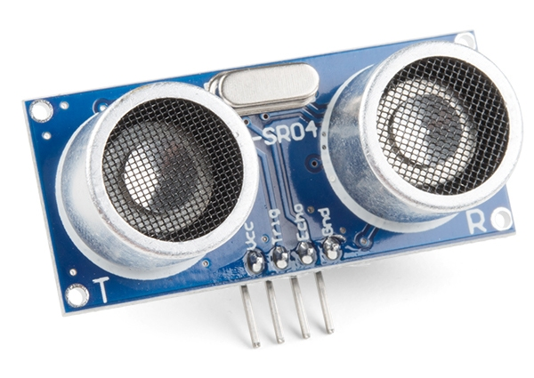
Note. Image from SparkFun Electronics, n.d..
The HC-SR04 measures distance with sound. When its TRIG pin receives a short pulse, it sends out a 40kHz ultrasonic burst and raises its ECHO pin until the echo returns. The width of that pulse gives the distance, over a range of about 2cm to 4m. The sensor runs on 5V.
In Smart-Bin it is mounted under the lid facing down, so it measures the distance from the lid to the top of the trash. The firmware converts that distance into the fill percentage shown on the LED, the touchscreen and the apps, and a reading of 80% or more starts the full-bin alert. TRIG connects to IO5, and ECHO reaches IO18 through a 1kΩ and 2.2kΩ divider so the 5V pulse does not exceed the ESP32's 3.3V input.
Figure 9
HC-SR501 PIR Motion Sensor
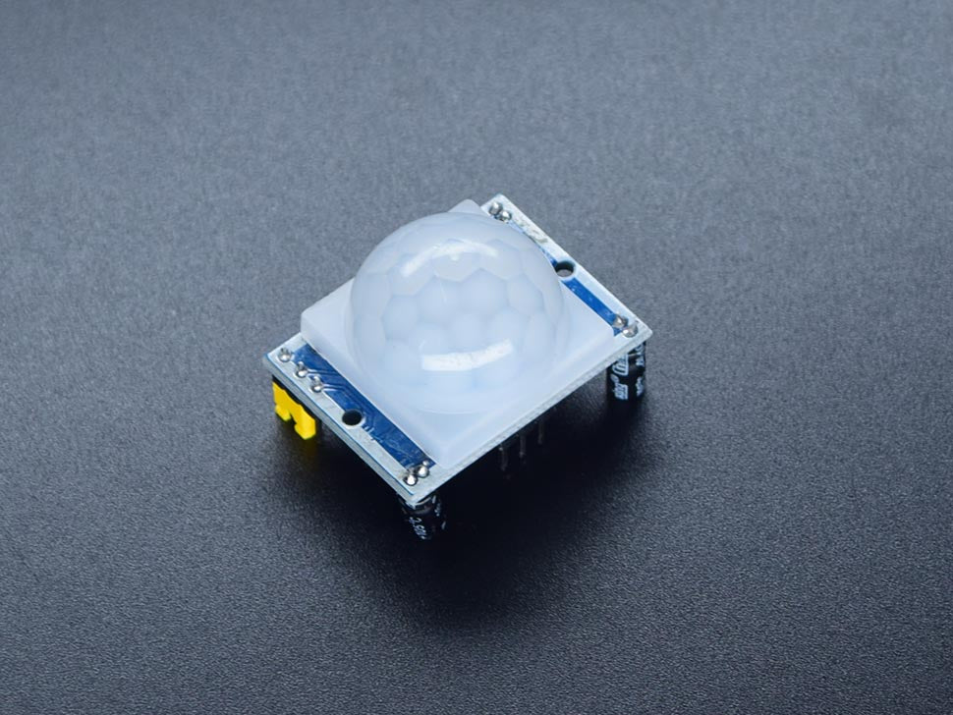
Note. Image from Circuitrocks, n.d.-c.
The HC-SR501 is a passive infrared (PIR) sensor. It detects the change in infrared light when a warm body moves in front of its white dome lens, and its output pin goes high while motion is seen. Two trimmers on the board set the sensitivity and how long the output stays high.
Smart-Bin uses it to know when someone walks up to the bin. When the output on IO27 goes high and the bin is free to open, the bin beeps and the servo lifts the lid, so the user never has to touch it. The lid closes 5s after motion stops. Motion sensing is paused during COLLECT mode so the lid stays open while the collector works.
Figure 10
BME680 Environmental Sensor
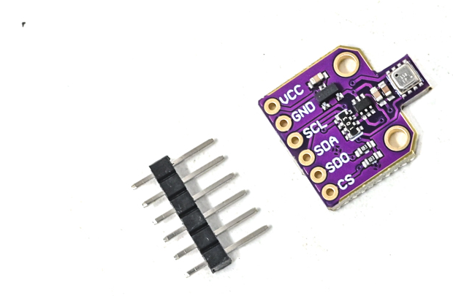
Note. Image from Robu.in, n.d..
The BME680 measures temperature, humidity, air pressure and volatile organic gases in a single chip. The gas reading can be turned into an indoor air quality (IAQ) index. It runs on 3.3V and talks over I2C.
In Smart-Bin it watches the air inside the bin. Rotting waste raises the gas reading, and a fire or hot material raises the temperature, so the firmware raises an alert when heat or bad air passes its limit, even if the bin is not yet full. It sits on the I2C bus at address 0x76, set by tying SDO to ground.
Figure 11
BMI160 Six-Axis Inertial Measurement Unit
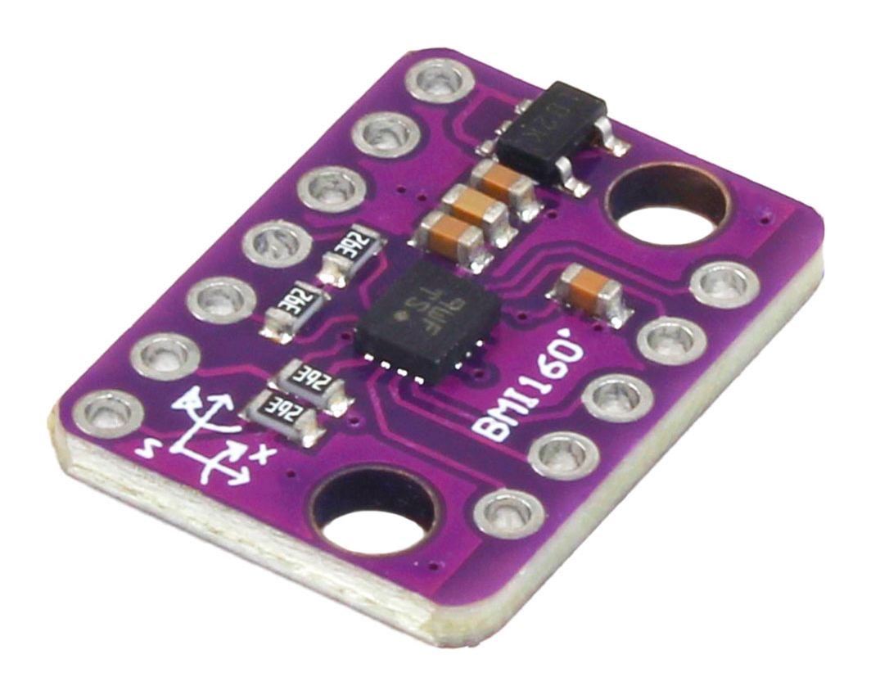
Note. Image from ElectroPeak, n.d..
The BMI160 combines a three-axis accelerometer and a three-axis gyroscope in one chip. It reports acceleration and rotation over I2C and runs on 3.3V.
Smart-Bin uses it for tamper detection. If the bin is tilted, shaken or knocked over, the readings jump past their limits and the firmware flags a tamper, sounds the buzzer alarm and keeps the lid shut. It shares the I2C bus with the BME680 at address 0x68, set by tying SA0 to ground. The tamper check is paused during COLLECT mode.
Figure 12
HX711 Load Cell Amplifier and 5kg Load Cell
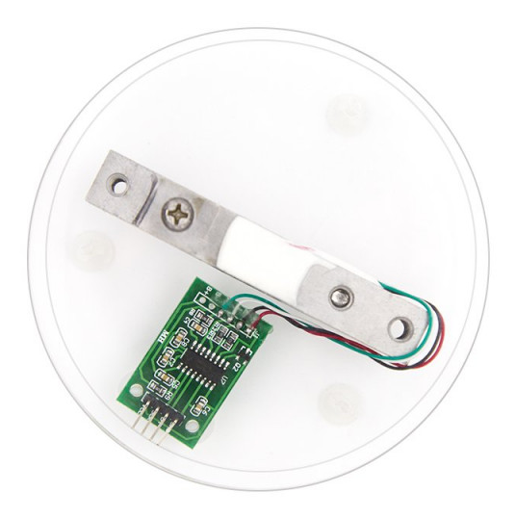
Note. The HX711 board and the 5kg load cell are shown on a display base. Image from ElectronicsComp.com, n.d..
A load cell is a metal bar fitted with strain gauges whose resistance changes slightly as weight bends the bar. The 5kg bar used here outputs a very small voltage, so the HX711 board amplifies it and converts it with a 24-bit analog-to-digital converter. The ESP32 reads the result through two pins, DT on IO32 and SCK on IO14.
The pair weighs the trash. Weight adds a second check on top of the ultrasonic fill level, since a bin can be heavy but not tall, as with wet waste. The weight appears on the dashboard and the app and is logged to the cloud with each reading.
Figure 13
SG90 Micro Servo Motor
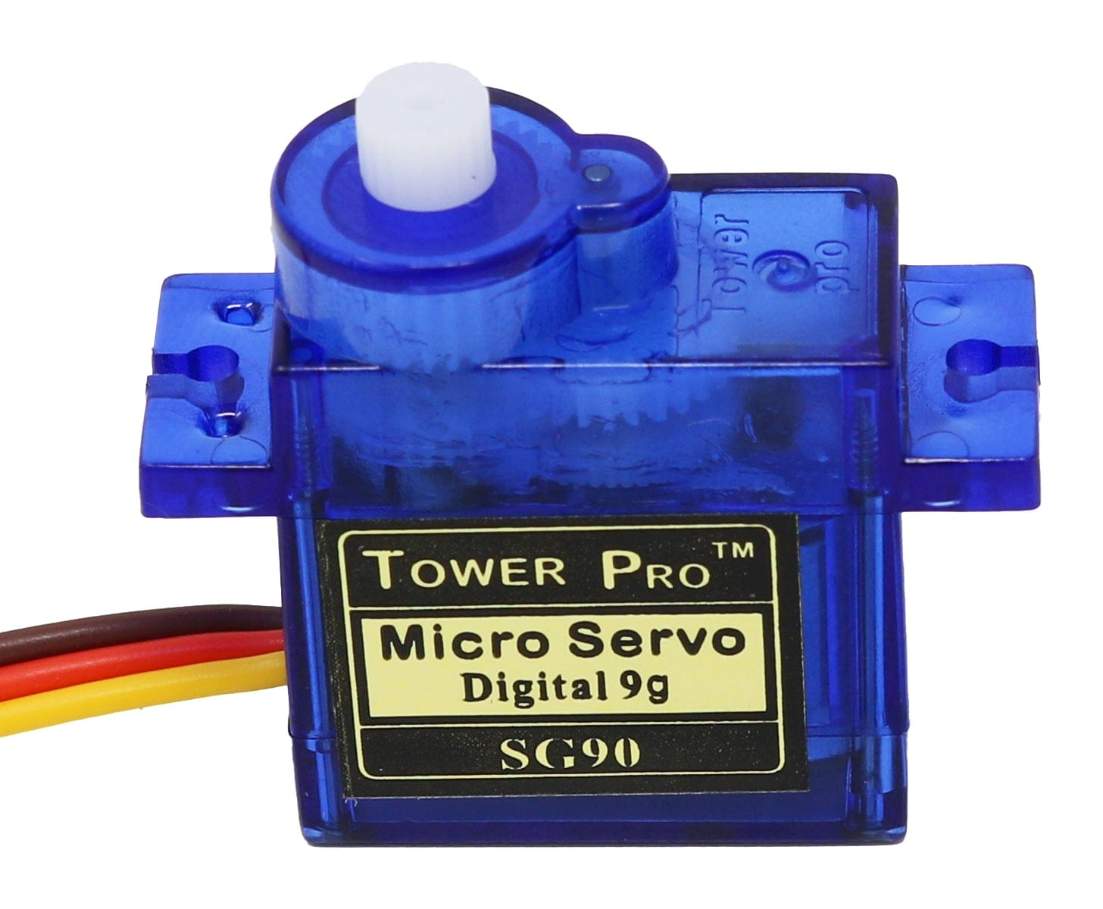
Note. Image from The Pi Hut, n.d..
The SG90 is a small hobby servo that turns its output arm to a set angle, across about 180°, based on the width of a PWM pulse. It runs on about 5V and is light enough to mount directly on the bin.
The servo opens and shuts the bin lid. The ESP32 drives it from IO13, opening the lid when a user is detected or when the collector taps COLLECT, and closing it 5s after motion stops or when the collector taps DONE. When the bin is locked, full or flagged for tampering, the firmware keeps the servo in the closed position.
Figure 14
2.4-in. TFT Touchscreen (ILI9341 With XPT2046 Touch Controller)
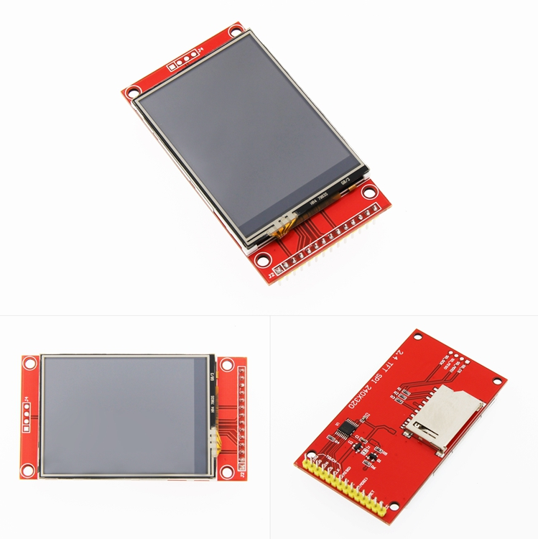
Note. Front, back, and angled views of the module. Image from LCDWIKI, n.d..
This module is a 2.4 in., 240 × 320 color display driven by the ILI9341 controller over SPI. A resistive touch layer on top is read by a separate XPT2046 controller on the same SPI bus. The board also carries an SD card slot, which Smart-Bin does not use.
The display is the bin's local screen. It shows the fill level, the sensor readings and the bin status, including LOCKED and TAMPER messages. The touch layer gives the collector the COLLECT, PIN and DONE buttons, so a bin can be emptied even without the app.
Figure 15
KY-016 RGB LED Module
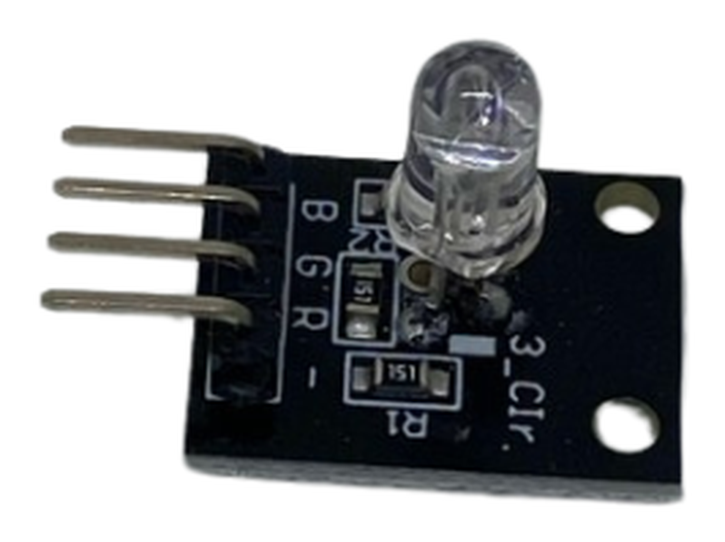
Note. Image from Circuitrocks, n.d.-d.
The KY-016 is a small board carrying a common-cathode RGB LED, which holds red, green and blue chips in one package. Mixing the three colors gives other shades, such as amber from red and green. Each color is driven through a 1kΩ resistor.
The LED shows the fill level at a glance: green when the bin has room, amber as it fills, and red when it is full or an alert is active. It is driven from IO25, IO26 and IO33, and it turns green again when the collector taps DONE.
Figure 16
Passive Buzzer Module (MH-FMD)
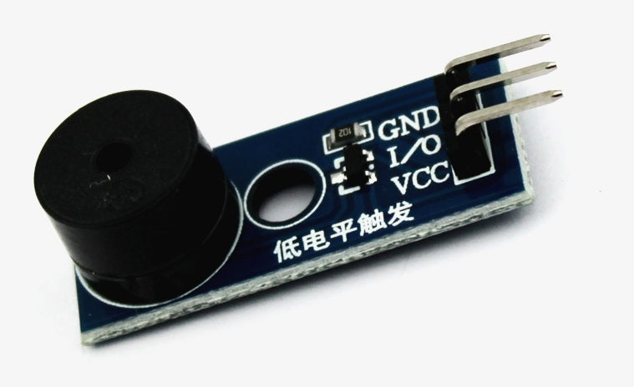
Note. Image from QuartzComponents, n.d..
A passive buzzer has no built-in oscillator, so it sounds only when the controller drives it with a changing signal. This lets the firmware play different tones and patterns instead of one fixed beep.
Smart-Bin uses it for sound feedback from IO12. It beeps when the lid opens for a user, gives warning tones when the bin is full or the air is bad, and sounds the alarm when the BMI160 detects tampering. It is silenced during COLLECT mode.
Figure 17
18650 Battery Shields for Bin A (4-Cell) and Bin B (2-Cell)
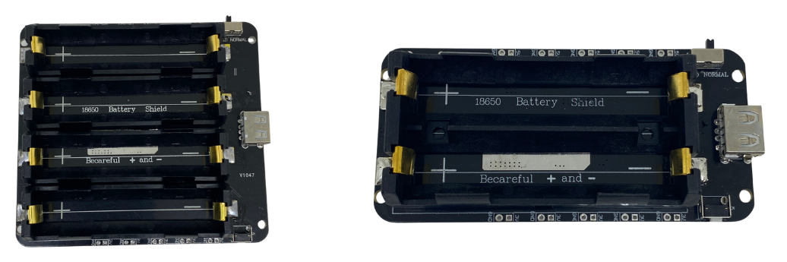
Note. Left: four-cell shield used in Bin A (Circuitrocks, n.d.-b). Right: two-cell shield used in Bin B (Circuitrocks, n.d.-a).
An 18650 battery shield holds lithium-ion 18650 cells and turns their voltage into regulated 5V and 3.3V outputs. It also has a USB port for charging the cells. Bin A uses a four-cell V9 shield rated 5V/3A, and Bin B uses a two-cell shield.
The shield powers the whole bin without a wall outlet, so a bin can be placed anywhere within Wi-Fi range. It sits in a sealed compartment and feeds the ESP32's 5V pin, and the ESP32 then supplies 3.3V to the sensors. The schematic notes that the battery must not be connected while code is being uploaded over USB.

III. TESTING, RESULTS, AND CONCLUSION

3.1 Test Cases
[Introduce the test cases here. Each specific objective is tested below.]

Specific Objective 1: Sensor Monitoring and Detection
[Insert test cases TC1.1 to TC1.6 here.]

Specific Objective 2: Real-Time Monitoring and Alerts
[Insert test cases TC2.1 to TC2.6 here.]

Specific Objective 3: Bin Control and Collection Prioritization
[Insert test cases TC3.1 to TC3.6 here.]

3.2 Results and Discussion
[Present and discuss the test results here.]

3.3 Conclusion
[Write the conclusion here.]

3.4 Recommendations
[Write the recommendations here.]

REFERENCES
Circuitrocks. (n.d.-a). 2 channel 18650 battery holder protection board. Retrieved October 15, 2026, from https://circuit.rocks/products/2-channel-18650-battery-holder-protection-board
Circuitrocks. (n.d.-b). 4 channel 18650 battery holder protection board. Retrieved October 15, 2026, from https://circuit.rocks/products/4-channel-18650-battery-holder-protection-board
Circuitrocks. (n.d.-c). HC-SR501 PIR motion sensor module. Retrieved October 15, 2026, from https://circuit.rocks/products/pir-motion-sensor-module-digital
Circuitrocks. (n.d.-d). KY-016 RGB 3 color full-color LED module. Retrieved October 15, 2026, from https://circuit.rocks/products/ky-016-rgb-3-color-full-color-led-module
ElectronicsComp.com. (n.d.). 5 kg load cell with HX711 module shell and 4P DuPont wire kit. Retrieved October 15, 2026, from https://www.electronicscomp.com/5-kg-load-cell-with-hx711-module-shell-and-4p-dupont-wire-kit
ElectroPeak. (n.d.). GY-BMI160 module 6DOF 6 axis angular velocity. Retrieved October 15, 2026, from https://electropeak.com/gy-bmi160-module-6dof-6-axis-angular-velocity
LCDWIKI. (n.d.). 2.4inch SPI module ILI9341 SKU:MSP2402. Retrieved October 15, 2026, from https://www.lcdwiki.com/2.4inch_SPI_Module_ILI9341_SKU:MSP2402
Leones, J. R. (2025, March 3). Philippines ministerial statement [Paper presentation]. High-Level 12th Regional 3R and Circular Economy Forum in Asia and the Pacific, Jaipur, India. https://uncrd.un.org/sites/uncrd.un.org/files/12th3r_ps1-philippines.pdf
Philippine Statistics Authority. (2026). Highlights of the Compendium of Philippine Environment Statistics 2016–2025, Component 3: Residuals. https://psa.gov.ph/statistics/environment-statistics/highlights/component-3-residuals
QuartzComponents. (n.d.). Passive buzzer module with PCB. Retrieved October 15, 2026, from https://quartzcomponents.com/products/passive-buzzer-module
Robu.in. (n.d.). BME680 digital temperature humidity pressure sensor CJMCU-680 high altitude sensor module development board. Retrieved October 15, 2026, from https://robu.in/product/bme680-digital-temperature-humidity-pressure-sensor-cjmcu-680-high-altitude-sensor-module-development-board/
Sigmanortec. (n.d.). ESP32-DevKitC ESP32-WROOM-32D WiFi BT 38P development board. Retrieved October 15, 2026, from https://sigmanortec.ro/en/esp32-devkitc-development-board-esp32-wroom-32d-38p
SparkFun Electronics. (n.d.). Ultrasonic distance sensor - 5V (HC-SR04). Retrieved October 15, 2026, from https://www.sparkfun.com/ultrasonic-distance-sensor-hc-sr04.html
The Pi Hut. (n.d.). TowerPro servo motor - SG90 analog. Retrieved October 15, 2026, from https://thepihut.com/products/towerpro-servo-motor-sg90-analog
United Nations Department of Economic and Social Affairs. (n.d.). Goal 11: Make cities and human settlements inclusive, safe, resilient and sustainable. https://sdgs.un.org/goals/goal11
World Bank. (2022). An assessment of municipal solid waste plans, collection, recycling and disposal of Metro Manila (East Asia and Pacific Region: Marine Plastics Series). https://documents1.worldbank.org/curated/en/099125007222250938/pdf/P170994059e8e308c0a3ec02e0c4f57778b.pdf

APPENDICES

Appendix A: Gantt Chart
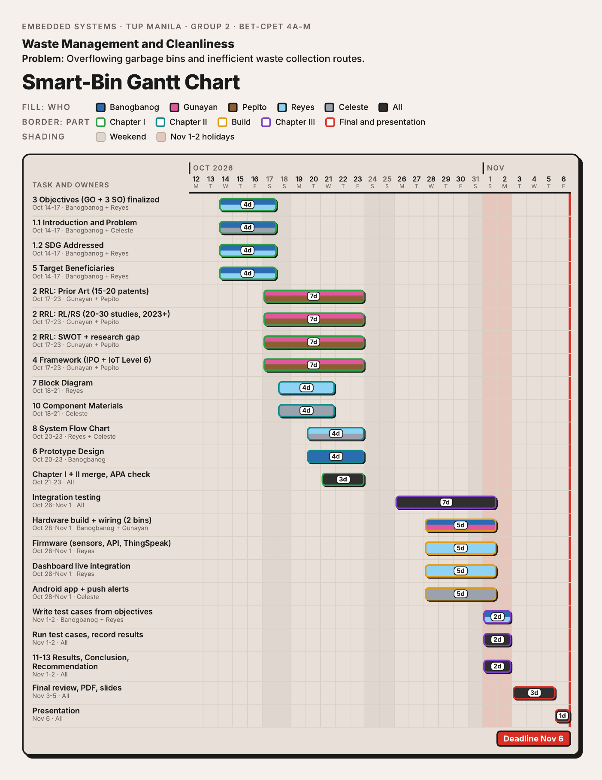

Appendix B: Bill of Materials
Table 1
Bill of Materials of the Smart-Bin Prototype
Component | Qty | Unit price | Amount
ESP32 DevKit V1 (38-pin, WROOM-32D) | 2 | ₱250.00 | ₱500.00
HC-SR04 ultrasonic sensor | 2 | ₱45.00 | ₱90.00
HC-SR501 PIR motion sensor | 2 | ₱55.00 | ₱110.00
SG90 micro servo motor (180°) | 2 | ₱65.00 | ₱130.00
2.4-in. TFT touch display (ILI9341 + XPT2046) | 2 | ₱280.00 | ₱560.00
BMI160 six-axis inertial sensor module | 2 | ₱80.00 | ₱160.00
BME680 environmental sensor | 2 | ₱400 | ₱800
HX711 load cell amplifier board | 2 | ₱60.00 | ₱120.00
5kg straight bar load cell | 2 | ₱120.00 | ₱240.00
RGB LED (common cathode, 5mm) | 2 | ₱8.00 | ₱16.00
Passive buzzer module (5V) | 2 | ₱12.00 | ₱24.00
Total (priced items) |  |  | ₱2,630.00
Note. Quantities cover both bins unless a row names one bin. Unit prices are from the group’s Shopee Philippines check in September 2026, and owned parts are counted at that market price.

Appendix C: User Interface Screens
[Insert screenshots of the touchscreen, web dashboard, and Android app here.]

Appendix D: Source Code
[Insert the firmware source code or a link to the repository here.]

